C.V.  Jeppe Schroeder  height: 180cm  veight: 69kg  eyes: blue  hair: brown  born: 1972  Trained at:  Arts Educational School of Acting | 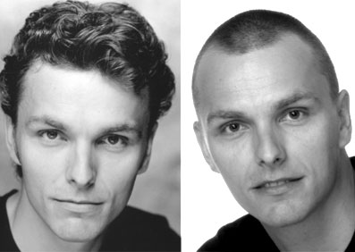

Most Important Shows

-"Den Blå Karrusel", Director Daniel Bohr, Tour of Denmark, William 2006
-"Frode & alle de andre rødder", Director Jan Hertz, Glassalen Tivoli, Frode 17.02.05-06.03.05 Tour of Denmark, 22.02.06-15.03.06
-"The Sound of Music", Director Daniel Bohr, Det Ny Teater, Rolf 01.03.04-28.11.04- "West Side Story", Director Ronny Danielsson, Malmö Opera & Musikteater, Baby ..John 2003-04
- ”Show Boat”, Director Morten Hovman, Aarhus Teater, ensemble, ….06.09.02-..26.10.02
- ”Miss Saigon”, Director Lisa Kent, Aarhus & Odense Teater, ensemble, ….30.07.01-..12.01.02
- ”Caribisk Krydstogt”, Openwide, skib: Sundream, Lead Male, 01.10.99-….11.04.00
- ”Ellegies”, Director David Robson, Turnham Green Theatre, Brian, ….1999
- ” The Innocent Mistress”, Director Andrew Visnevski, T.G.T., Spendall, ….1998

At Arts Ed.

- Man of La Mancha, Director Nicholas Tudor, Padre
- The provoked Wife, Director Terry Fender, Constant
- Commedia dell’arte, Director Stephen Hutton, Lover
- All My Sons, Director Robert Fried, George

Special Skills

Singing: Tenor G-C

Language: RP, General American, and of course Danish

Has Taken
- The British Academy of Dramatic Combat Advanced Certificate
- Padi advanced open water diver
- Clean dirving lisence
www.jeppe-s.dk e-mail: j@jeppe-s.dk mobil tlf. 40 52 15 79

